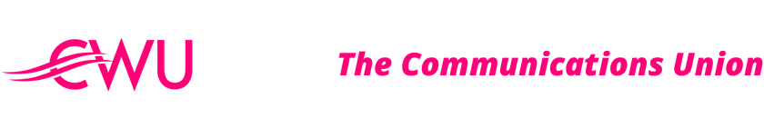
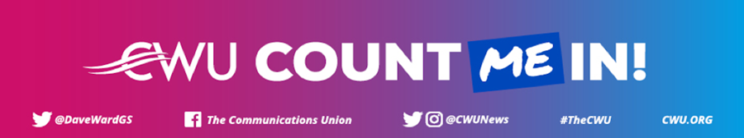
TO: ALL MEMBERS IN BT, EE AND OPENREACH
COUNT ME IN CAMPAIGN – AGREEMENT REACHED WITH BT GROUP
8th July 2021
Dear Member,
We are pleased to announce that after a period of intensive negotiations, we have reached an agreement with the company, across all CFU’s, covering a wide range of issues
The CWU Executive has endorsed the agreement and we will now set out a clear programme of communications to engage you on the settlement in the coming weeks.
The agreement represents a huge turnaround from where we were 18 months ago, and I want to be absolutely clear - this is because of the Count Me In campaign and the outstanding support we have received from our branches and members.
Better Workplace - We have moved from the position of arbitrary change to one of negotiation. We genuinely believe the agreement we have reached will: protect jobs; puts the union back in the room; and delivers a new framework, which moves BT away from making knee-jerk decisions, without our agreement.
Pay – We were told 18 months ago there was no money for pay. The pressure of the campaign forced BT into making the £1000 Bonus payment. We do not agree that this is enough but through these negotiations, it has been clear that pay is a major issue for the employer. Despite this, we have agreed a plan for simplifying and resolving currently unagreed pay points, which will benefit a significant number of CWU members, and we have also secured a commitment to a consolidated pay rise for all CWU Represented Grades in April 2022. None of this was on the table before our campaign.

Redundancy – BT were moving ahead, at pace, with an unagreed plan which would have cut thousands of jobs. Change will still happen, but it will be negotiated, and we will see proper consultation and engagement. We have secured protections for our members in this area and the chance for the union to input directly – at Group level – into the future strategy.
This agreement will increase job security, secure UK based roles, implement fairer grading and pay structures, see the opportunity for upskilling and see the union become a powerful stakeholder rather than an observer to BT’s plans.
The employer’s strategy is a long term one and that will mean this agreement is a living and breathing document. With this in mind, we will continue to engage members throughout the coming months on any progress (or otherwise) we make with the company. It is crucial that despite reaching agreement, we maintain the pressure and momentum that we achieved with the Count Me In campaign. It is this approach which has shifted BT Group.
In the coming weeks we will engage with members on the full terms of the agreement via podcasts, videos, and email.
My final message is one of thanks. The work that has been done, across the union in the last 18 months has been incredible. We have gained new members, representatives, and activists. It is because of your work and the countless meetings and communications that we are in a more positive position.
I look forward to communicating further with you all next week.

Yours sincerely,

Andy Kerr
Deputy General Secretary (T&FS)

